**Issue Title** - **Processes - HRStage - Interviewer y Delegate information only appears when you click anywhere else over the form**

**Environment – Test, Role - Admin**

**Expected**: Interviewer and Delegate fields should be filled with saved information.

**Actual:** Delegate field have information but Interviewer field does not have any information.

**QA Status: FAIL**

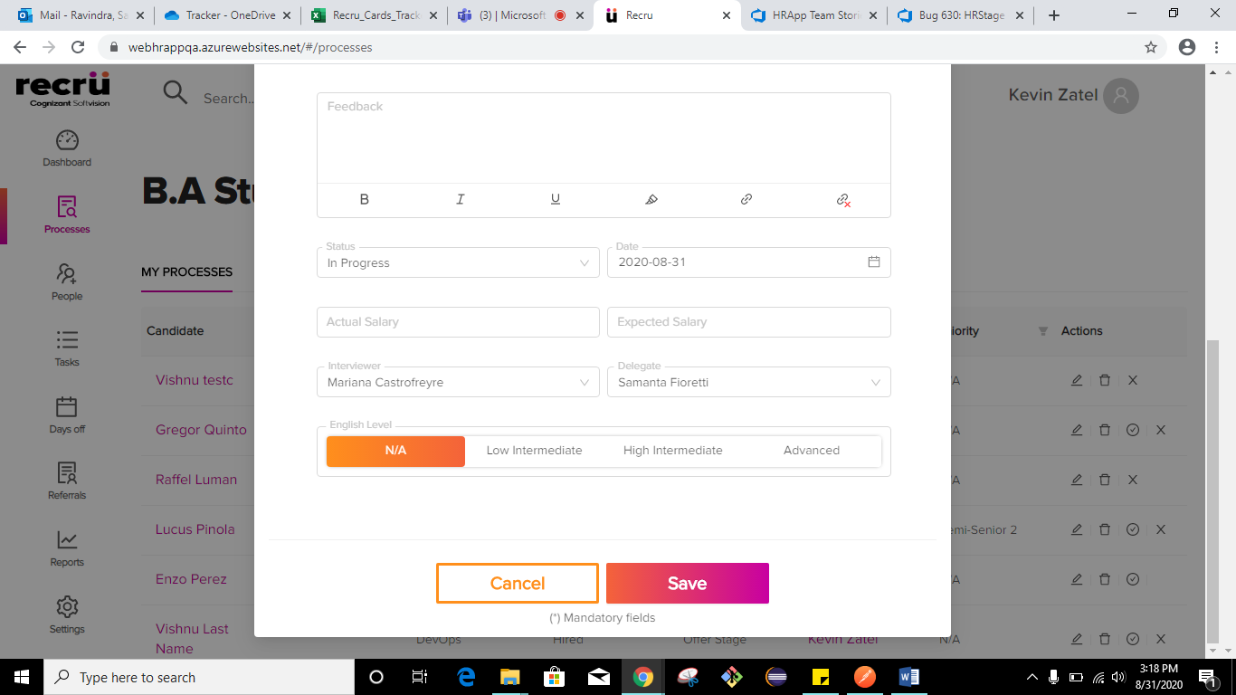

2.

